St Pius X Catholic Parish Heidelberg West acknowledges the Wurundjeri people.

Fr Wayne Edwards: St Pius X Presbytery 419 Waterdale Rd Heidelberg West 3081

Tel: 9457 5794 Fax: 9457 1036 Email: heidelbergwest@cam.org.au

Exodus Community: 273 Liberty Parade Heidelberg West Tel: 9457 7593

School Principal: Barbara Gomez Tel: 9457 3776 Email: bgomez@spxhw.catholic.edu.au

_________________________________________________________________________________________________

MASS TIMES

Sundays Saturday Vigil 7pm Sunday 9am & 11.00am

Exodus Community, 12 Noon in the shed at 273 Liberty Pde, Heidelberg West

Weekdays 9am Tuesday, Wednesday, Thursday, Friday, Saturday

CONFESSIONS & ROSARY After 9am Mass on Saturday mornings

CHURCH OPEN FOR PRAYER 8.30am – 4pm on school days only

PARISH WEBSITE - pol.org.au/heidelbergwest

St Pius X Catholic Church Heidelberg West actively works to listen to, empower and protect children, and has zero tolerance for child abuse and neglect.

PLEASE LOOK AFTER YOUR CHILDREN WHILE MASS IS IN PROGRESS
SAINTS/FEAST DAYS FOR THE WEEK
- Tuesday 31 – The Visitation of the Blessed Virgin Mary
- Wednesday – 1 St Justin
- Friday 3 – Charles Lwanga

Reflection: “I am the Alpha and the Omega, the first and the last, the beginning and the end.” (REVELATIONS 22:13)
This is a reminder of how we should live our lives 24 hours a day, 7 days a week – putting God first in all that we do. Not only when I am at Mass and parish activities, but when I am in the world, at work or at school. Living gratefully and generously is an intentional lifestyle. Every decision you make either moves you closer to God or farther away. Choose wisely!

BOOKS TO BORROW A borrowing library has been set up in the Church foyer. Please feel free to borrow a book and return once finished. If you have any AS NEW BOOKS we are happy for you to add them to our collection. (Please no tattered or old books)
2022 MASS COUNTS
Last weekend of Mass counts 28-29 May. Thank you for your cooperation and kind assistance.
Next Sunday: June 5th
 | Reader | Special Ministers
Saturday 7:00pm | Phoebe Davies
Sunday 9:00am | Len Doublet
Sunday 11:00am | Felicity Paolucci
NEXT SUNDAY’S READINGS – PENTECOST SUNDAY
Gen 11 1-9; Ps 103 1-2, 24, 27-30, 35; Rom 8: 22-27

COLLECTIONS LAST WEEKEND
Presbytery $579.00 | Loose $829.00 | Thanksgiving $1020.00

CATHOLIC MISSION APPEAL – THANK YOU
Thank you so much for your generous partnership with life-changing mission programs like the establishment of the Deberety Goat Rearing Centre in Emdibir, Ethiopia. Your gift is helping the Church and the local community work towards constructing the Centre, supplying feed and veterinary medication, and procuring goats to provide nutritious milk to help address problems like malnutrition in babies and children. Your gift also supports mission programs around the world that reach out and give life to those in most need. If you missed your opportunity to learn about this vital mission program, or wish to contribute again, please go to catholicmission.org.au/ethiopia or Free call: 1800 257 296

Prayers for the Sick; David Tickner, Pauline Curlis, Joy Opie
For the Recently Departed: Gwen Eccles, Maria Truong
Anniversary of Death: Violet Buntz, Johanna Buntz, Ellen Galvin, Salvatore Farrugia, Lorraine Streiff, Barbara Caspersz, David Cortissos, Norm Coyne, Neil Smith,

NATIONAL RECONCILIATION WEEK 2022 (27 MAY – 3 JUNE)
Banyule Churches Together Week of Prayer for Christian Unity 2022
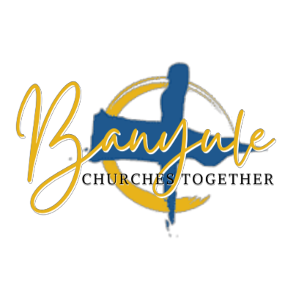
Sunday 29 May 2022
5pm Sung Evening Prayer at St Georges East Ivanhoe
47-51 Warncliffe Road Ivanhoe East 3079
Monday 30 May 2022
8am Morning Prayer at St Georges East Ivanhoe
Tuesday 31 May 2022
5pm service led by Rev’d Paul Blacker Banyule Network of Churches, Uniting Church, 19 Seddon St, Ivanhoe
Wednesday 1 June 2022
11am service led by Rev’d Craig Wright at Ivanhoe Baptist Church
1 Livingstone Street Ivanhoe 3079
Thursday 2 June 2022
9am Mass St Pius X Church, 419 Waterdale Rd, Heidelberg West
Friday 3 June 2022
Nil
Saturday 4 June 2022
6pm Vigil Mass at St. Bernadette’s Catholic Church will mark at the conclusion of the Week of Prayer for Christian Unity 2022, 89 Bond St Ivanhoe 3079

